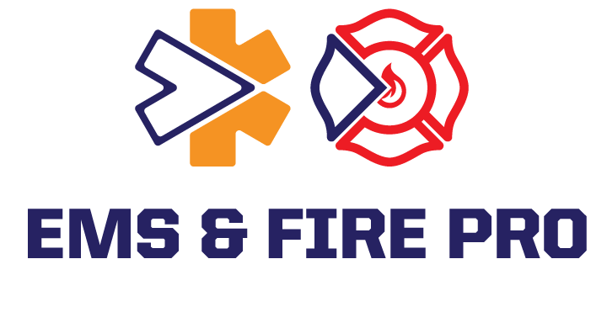

[First Name]
[Title]
[Company Name]
[Address]
[City, State, Zip]

Passport Number:
Date of Issue: Date of Expiration:
Place of Issue: Date of Birth:

Dear [First Name],
On behalf of EMS PRO, Inc., we are pleased to invite you to attend the EMS & FIRE PRO Expo, taking place at Mohegan Sun in Uncasville, Connecticut, USA.
The EMS PRO Expo is designed to place the focus on you by PROviding access to the industry's most PROlific speakers, PROgressive exhibitors, and PROvocative networking opportunities. This premier educational event brings together emergency medical services professionals from around the world to learn, collaborate, and advance the future of prehospital care.
This year's Expo is expected to attract more than 2,500 EMS professionals who will gather to participate in high-quality educational sessions, discover the latest products and technologies, and exchange ideas with colleagues from across the United States and around the globe. The conference offers an exceptional opportunity to enhance clinical knowledge, strengthen professional relationships, and improve the quality of patient care within your organization.
Please note that EMS & FIRE PRO Expo does not provide travel reimbursement, honoraria, lodging, meals, or any other form of financial compensation for attendees. Your travel to the United States is solely for the purpose of attending the EMS PRO Expo and participating in conference-related educational and professional activities on behalf of your organization.
If you have any questions regarding registration or the conference, please contact us at
+1 (866) 745-5424 or email info@emspro.org.

We look forward to welcoming you to the EMS PRO Expo and hope you will join us for an outstanding educational and networking experience.
Sincerely,
Greg Allard
President

